

**IACTE / IATEPC Spring 2018 Joint Conference**

**Registration Form**

**Tuesday and Wednesday, April 17 and 18, 2018**

**Conference and reception hosted at:**

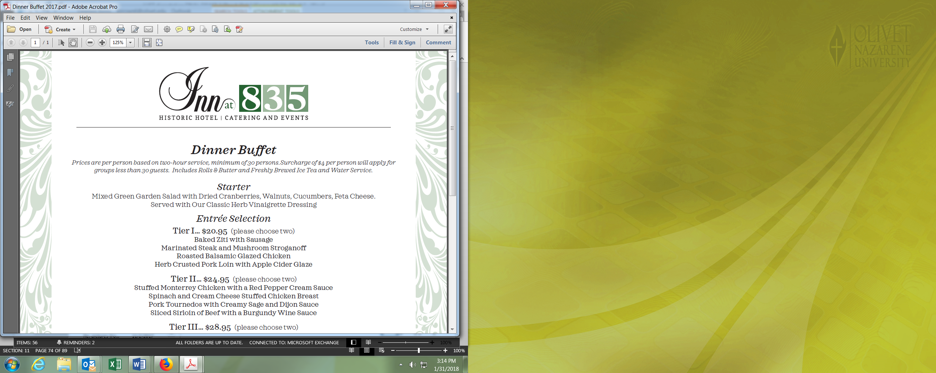

**835 S 2nd St, Springfield, IL 62704 -** [**Phone**](https://www.google.com/search?client=firefox-b-1&q=inn+at+835+phone&sa=X&ved=0ahUKEwjD-c3k3YLZAhVD2oMKHTt5AhwQ6BMIrQEwEQ)**:** [**(217) 523-4466**](https://www.google.com/search?q=inn+at+835&ie=utf-8&oe=utf-8&client=firefox-b-1)

Please make checks payable to **IACTE**

Once complete, **please mail this form and your check to:**

**Kelly Brown, IACTE Treasurer**

Olivet Nazarene University

School of Education 6043

One University Avenue

Bourbonnais, IL 60914

**Registration Fees:** Conference and Reception $75.00

Reception only $35.00

**IMPORTANT:**

Conference registration must be **received by April 4, 2018. Registration at the door is not available**

**College/University:** ______________________________________________________________

List names and e-mail addresses of registrants below. Select **one type of registration** for each registrant (**please print clearly**).

|  |  |  |  |  |
| --- | --- | --- | --- | --- |
| **Name** | **Email** | **Dietary Restrictions** | **Conference & Reception ($75.00)** | **Reception Only**  **($35.00)** |
|  |  |  |  |  |
|  |  |  |  |  |
|  |  |  |  |  |

**Total enclosed:** __________

**HOTELS (no blocks have been saved, these are only suggestions to help)**

|  |  |  |
| --- | --- | --- |
| **State House Inn**  101 E Adams St  Springfield, IL 62701  [Phone](https://www.google.com/search?client=firefox-b-1&hotel_dates=2018-02-04,2018-02-05&site=async/lcl_akp&q=statehouse+inn+phone&sa=X&ved=2ahUKEwjh4Zjfk4PZAhWG6oMKHRS9Cc0Q6BMwBXoECAAQGw): [(217) 528-5100](https://www.google.com/search?client=firefox-b-1&q=springfield+illinois+hotels&npsic=0&rflfq=1&rlha=1&rlla=0&rlhsc=Ch4IwKmLx7Se5OTKAQjNlLmzpq7zUAjs6e2rvaf4nSg&rllag=39782503,-89625976,2644&tbm=lcl&ved=0ahUKEwiU5sbhkYPZAhVG74MKHRUrAjkQtgMITA&hotel_dates=2018-02-04,2018-02-05&tbs=lf_hd:-1,lf_ho:2,lrf:!1m4!1u10!2m2!11m1!1e4!1m4!1u10!2m2!11m1!1e5!1m4!1u10!2m2!11m1!1e8!1m4!1u10!2m2!11m1!1e10!1m4!1u10!2m2!11m1!1e2!1m4!1u10!2m2!11m1!1e3!1m4!1u10!2m2!11m1!1e7!2m7!1e17!4m2!17m1!1e3!4m2!17m1!1e8!2m1!1e2!2m1!1e4!2m22!1e10!4m2!11m1!1e4!4m2!11m1!1e5!4m2!11m1!1e8!4m2!11m1!1e10!4m2!11m1!1e2!4m2!11m1!1e3!4m2!11m1!1e7!2m21!1e7!4m4!7m3!1m1!1u75!3sUSD!4m4!7m3!1m1!1u125!3sUSD!4m4!7m3!1m1!1u150!3sUSD!4m4!7m3!1m1!1u175!3sUSD!3sIAE,lf:1,lf_ui:6&rldoc=1) | **Wyndham Springfield City** Centre700 E Adams St,  Springfield, IL 62701  [(217) 789-1530](https://www.google.com/search?client=firefox-b-1&q=springfield+illinois+hotels&npsic=0&rflfq=1&rlha=1&rlla=0&rlhsc=Ch4IwKmLx7Se5OTKAQjNlLmzpq7zUAjs6e2rvaf4nSg&rllag=39782503,-89625976,2644&tbm=lcl&ved=0ahUKEwiU5sbhkYPZAhVG74MKHRUrAjkQtgMITA&hotel_dates=2018-02-04,2018-02-05&tbs=lf_hd:-1,lf_ho:2,lrf:!1m4!1u10!2m2!11m1!1e4!1m4!1u10!2m2!11m1!1e5!1m4!1u10!2m2!11m1!1e8!1m4!1u10!2m2!11m1!1e10!1m4!1u10!2m2!11m1!1e2!1m4!1u10!2m2!11m1!1e3!1m4!1u10!2m2!11m1!1e7!2m7!1e17!4m2!17m1!1e3!4m2!17m1!1e8!2m1!1e2!2m1!1e4!2m22!1e10!4m2!11m1!1e4!4m2!11m1!1e5!4m2!11m1!1e8!4m2!11m1!1e10!4m2!11m1!1e2!4m2!11m1!1e3!4m2!11m1!1e7!2m21!1e7!4m4!7m3!1m1!1u75!3sUSD!4m4!7m3!1m1!1u125!3sUSD!4m4!7m3!1m1!1u150!3sUSD!4m4!7m3!1m1!1u175!3sUSD!3sIAE,lf:1,lf_ui:6&rldoc=1) | **President Abraham Lincoln DoubleTree by Hilton**  701 E Adams St  Springfield, IL 62701  [(217) 544-8800](https://www.google.com/search?client=firefox-b-1&q=springfield+illinois+hotels&npsic=0&rflfq=1&rlha=1&rlla=0&rlhsc=Ch4IwKmLx7Se5OTKAQjNlLmzpq7zUAjs6e2rvaf4nSg&rllag=39782503,-89625976,2644&tbm=lcl&ved=0ahUKEwiU5sbhkYPZAhVG74MKHRUrAjkQtgMITA&hotel_dates=2018-02-04,2018-02-05&tbs=lf_hd:-1,lf_ho:2,lrf:!1m4!1u10!2m2!11m1!1e4!1m4!1u10!2m2!11m1!1e5!1m4!1u10!2m2!11m1!1e8!1m4!1u10!2m2!11m1!1e10!1m4!1u10!2m2!11m1!1e2!1m4!1u10!2m2!11m1!1e3!1m4!1u10!2m2!11m1!1e7!2m7!1e17!4m2!17m1!1e3!4m2!17m1!1e8!2m1!1e2!2m1!1e4!2m22!1e10!4m2!11m1!1e4!4m2!11m1!1e5!4m2!11m1!1e8!4m2!11m1!1e10!4m2!11m1!1e2!4m2!11m1!1e3!4m2!11m1!1e7!2m21!1e7!4m4!7m3!1m1!1u75!3sUSD!4m4!7m3!1m1!1u125!3sUSD!4m4!7m3!1m1!1u150!3sUSD!4m4!7m3!1m1!1u175!3sUSD!3sIAE,lf:1,lf_ui:6&rldoc=1) |

**IACTE FEIN/TIN: 23-7271311**