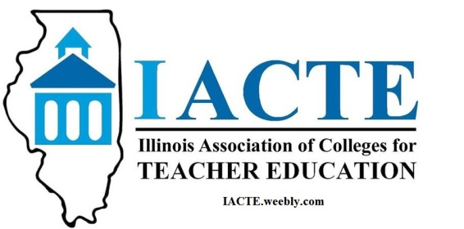

2018 Outstanding Beginning Teacher Award
Nominating Institutions of Higher Education

Augustana College
Aurora University
DePaul University
Dominican University
Eastern Illinois University
Eureka College
Governor State University
Judson University
Lake Forest College
Loyola University
MacMurray College
Milikin University
Roosevelt University
Southern Illinois University-Carbondale
Southern Illinois University-Edwardsville
St. Xavier University
Trinity International University
Western Illinois University

