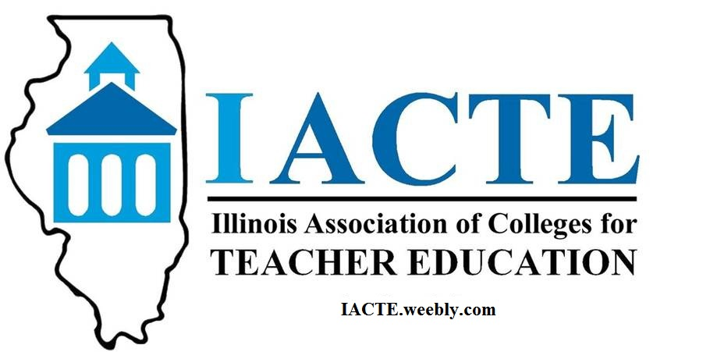

Guidelines for Outstanding Beginning Teacher Awards

The following guidelines are being provided to IACTE member institutions to help guide your nomination of Outstanding Beginning Teachers.

- Nomination forms will be available on the IACTE website (http://iacte.weebly.com) and with this communication.

- Nominating institutions should complete the Nomination Form, as well as prepare a short biographical statement of 200 words or less about the nominee, which can be used at the awards ceremony. Nominees will be asked to share a head shot for use in the program.

- The IACTE legislative reception and OBTA awards ceremony is scheduled for Tuesday, April 17, 2018. The due date for the nominations is March 13, 2018. Nominations should be sent to:
Thomas Sargent, IACTE Past President
Monmouth College
700 East Broadway
Monmouth, IL 61462
309.457.2310
tsargent@monmouthcollege.edu

- Once nominations have been received, the OBTA committee will follow up with an official letter of invitation to each nominee, their building administrator and to the nominating IACTE institution.

- Each nominating IACTE institution should contact its awardee and make financial arrangements to cover their travel and hotel expenses for coming to the ceremony and conference. Awardees do not have to register for the spring conference in order to attend the Legislative Reception for the awards ceremony. IACTE will pay for each nominee and their building administrator to have lunch on the first day of the conference.

- IACTE provides complimentary access to the reception for the honoree and one guest. If the nominating IACTE institution is not registered for the conference, the reception registration fee is $60 per person.

- In its notification of the award to the nominee’s building administrator, the IACTE OBTA committee will also send a request for the school district to cover the costs for a substitute teacher for one day.

- Please note that the Outstanding Beginning Teachers and administrators are also invited to participate in the Springfield Day on the Hill legislative visits on Wednesday, April 18, 2018.

- IACTE will work with the nominating IACTE institution to coordinate press release efforts. A standard press release will be available on the IACTE website after the event and can be downloaded by any institution or school district in order to provide information to local media regarding their award recipient.

